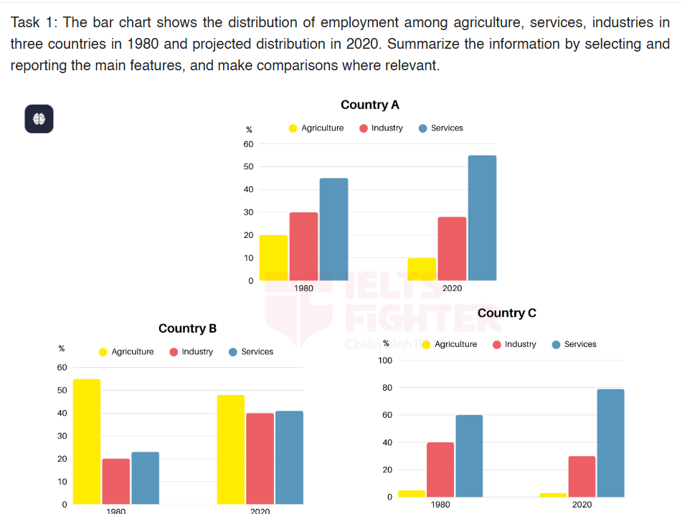
Task 2: Some people say it is more important to plant trees in the open spaces in towns and cities than to build more housing. To what extent do you agree or disagree?

